International Conference on Intelligent Knowledge Systems and Engineering Applications IKSEA’24

**NAVIGATION DEVICE FOR THE BLIND USING IOT**

Ch. Vidyadharia, L. Tharunb, M. Ashishc, L. Naren Kumard,

Kudakala Sai Krishnae, Haider Alabdelif, Ankit Puniag, Sakshi Kolih, Archana Sehgali

*aDepartment of Information Technology, Gokaraju Rangaraju Institute of Engineering and Technology, JNTUH, Bachupally, Hyderabad, India.*

*bDepartment of Computer Science & Engineering, KG Reddy College of Engineering and Technology, Chilkur, Moinabad, Hyderabad, India.*

*cDepartment of Computer Techniques Engineering, College of Technical Engineering, The Islamic University, Najaf, Iraq.*

*dCentre of Research Impact and Outcome, Chitkara University, Rajpura – 140417, Punjab, India.*

*eLovely Professional University, Phagwara, Punjab, India.*

Abstract

According to estimates presented by the World Health Organization, there are around 39 million people worldwide who are visually impaired or blind. They require more hands-on help to handle tasks. They deal with a lot of challenges on a regular basis. Thus, the project aims to offer an affordable and efficient solution that empowers visually impaired people to navigate with greater confidence, speed and compatibility.

The aim of an inventive technology like the wearable device for obstacle detection and navigation for the blind is to increase the safety and mobility of blind individuals. It is a wearable gadget that senses the presence of adjacent barriers using ultrasonic waves. It looks like a band or piece of fabric on the forehead. The user can then choose to receive vibrations or buzzer sounds as an alert from the gadget. As the user gets closer to the impediment, the sound or vibration gets stronger, enabling the user to change their direction and speed appropriately.

In this manner, the user can maneuver with greater accuracy and confidence while avoiding collisions and injuries. The user does not need to provide any manual input because the device is completely automated. It is an easy-to-use solution that can improve blind people's quality of life.

*Keywords:* Ultrasonic Obstacle Detection, Automated Navigation System, Disability Awareness.

**1. Introduction**

There are unique challenges associated with having vision problems. Simple everyday tasks that sighted people take for granted can become significant obstacles for the blind. Being blind or visually impaired does not indicate a lack of ability or capacity; rather, it represents a distinct way of relating to the outside world.

According to statistics from the W.H.O., 39 million people are blind worldwide, and each of them has different difficulties in their daily lives. The World Health Organization (WHO) classified the level of inability to see into various broad categories. This system was proposed to divide people based on their Distance vision impairment. There are numerous different types and intensities of visual impairments.

A person's function is not always well predicted by their visual acuity alone. Someone with poorer vision, such as 20/200 might still function effectively if their visual demands are relatively modest, someone with relatively high eyesight (e.g., 20/40) may find it difficult to go about their regular business. As a result, assessing a person's overall functioning depends on their access to therapy, as well as their situational and contextual circumstances.

**2. Proposed System**

We suggest an initiative to help the visually impaired live more comfortably leaving behind these difficulties. The goal of this project is to build a wearable device that detects obstacles using ultrasonic sensors and an Arduino board. Compared to current technologies, the device is intended to be more economical, accurate, and efficient.

The working of our system depends on the component ultrasonic sensor. The ultrasonic sensor measures the distance to a target by emitting ultrasonic sound waves, then interpreting the reflected waves into electrical signals. A transmitter and a receiver are the two primary parts that make up an ultrasonic sensor. The ultrasonic sound waves are produced by piezoelectric crystals in the transmitter1. When these sound waves come in contact with an obstacle, the waves get reflected or else continue traveling through the atmosphere until they are reflected back to the receiver.

The sensor determines the distance by measuring the time it takes for the sound waves to travel from the transmitter to the object and return to the receiver. This time is then used to calculate the distance to the object using the formula:

$$D=\frac{1}{2}T×C$$

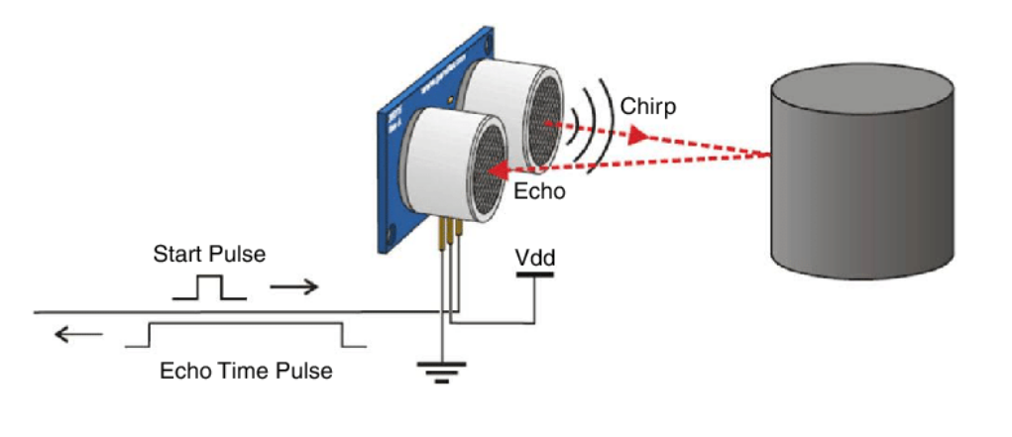

**Fig. 1. Working of an Ultrasonic sensor**

**3.Implementation**

**3.1. Device Specifications**

The system is built using an HC-SR04 ultrasonic sensor, Arduino Uno, 5V battery, buzzer, vibration motor, switch, jumper wires and a cloth band. The Arduino Uno works as the microcontroller, acting as the brain of the system. The buzzer and vibration motor serve as actuators that perform the action part, while the HC-SR04 acts as a sensor, handling the sensory tasks.

The System uses the HC-SR04 ultrasonic sensor due to its unique features, such as low power consumption, operation at 40kHz, a range of 2cm to 400cm and an accuracy of ±3 mm. It is very low-cost and highly available in the market, making it a go-to sensor for hobbyists and low-budget projects, which aligns with our goal of making the device cost efficient and effective.

The code is written using the Arduino software and then uploaded into Arduino Uno via a USB cable. The code contains both the logic and implementation aspects of the system. Arduino is the only software thing that is used in this project, everything else consists of hardware components.

**3.2. Device Assembly**

The system assembly for a “Navigation device for the Blind” project shown in the figure consists of a number of essential parts coupled to an Arduino Uno. The Arduino Uno, which acts as the setup’s central processing unit, is at its core. An HC-SR04 ultrasonic sensor, which gauges the separation between adjacent objects, is attached to it. The Trig and Echo pins of the sensor are linked to digital I/O pins on the Arduino for signal transmission and reception, the VCC and GND pins of the sensor are connected to the 5V and ground pins of the Arduino respectively.

A buzzer along with a vibration motor is also connected to the Arduino to provide auditory and tactile feedback respectively. Alongside the buzzer, a vibration motor is included for tactile feedback. The motor is connected to the Arduino through a transistor circuit to handle the current requirements, with its positive and negative leads connected to the transistor and ground, respectively.

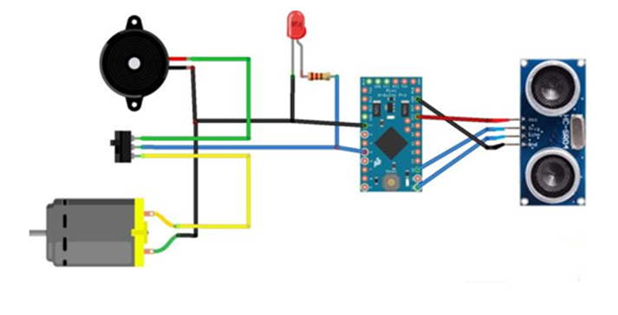

**Fig 2. Circuit Diagram**

After the assembly of the system the device will look something like the picture given below.

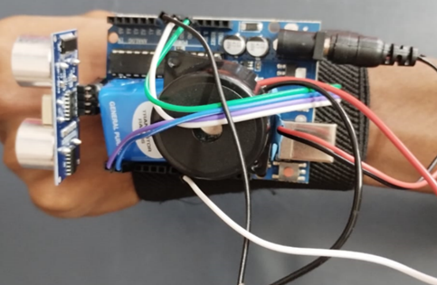

**Fig 3. The device in action**

This device can also be mounted on any other body parts and it can also be used with a walking stick. We mounted this over the hand but can also be used as per user requirements. The sensor must be placed in a position where it faces the obstacles the user wants to overcome.

**3.3. System Advantages**

Our project Navigation device for the blind does not require any sample data sets. The device reacts quickly, dynamically interprets live sensor input, and adjusts to changing circumstances. Your project stays responsive and effective whether it is gathering data, managing actuators, or keeping an eye on environmental parameters – all of which contribute to its value as a practical application. There are many advantages for real time execution in these types of devices based on IOT. With our environment being not uniform and unpredictable there might be a chance of any unexpected incident happening. That is the reason why we designed and implemented a system where in it has the following advantages –

• **Low Latency:** Real-time systems ensure minimal delay by reacting quickly to events. This leads to prompt data processing, quick decision-making, and effective control in Internet of Things applications.

• **Predictability:** Predictable behaviour is ensured by real-time scheduling. Important jobs, including keeping an eye on patients’ health or managing industrial processes, can adhere to tight deadlines.

• **Adaptive Systems:** IoT devices in real time adjust flexibly to changing circumstances. For example, altering irrigation schedules depending on weather forecasts or modifying traffic lights based on traffic density.

**4.Source Code**

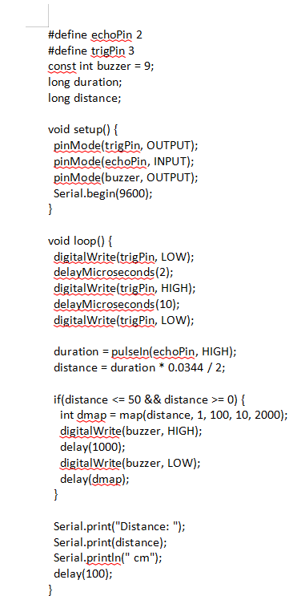

**Fig 4. Source Code**

**5. Result**

The output for the source code which has been implemented can be viewed in the serial monitor. It prints the distance between the device equipped by the user and the obstacle in front of it over a variable period of time.

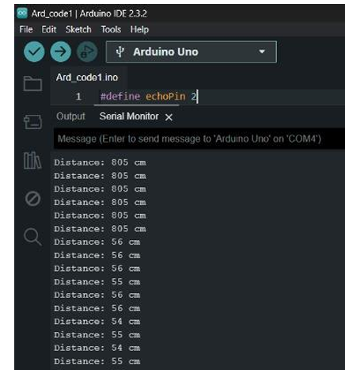

**Fig 5. Output in Serial Monitor**

**6.Conclusion**

The goal of the Navigation device for the blind using IOT project is to create a product that will be extremely helpful to persons who are visually impaired. Navigation device for the blind using IOT project is an invention that makes it easier for blind people to move quickly and confidently around by utilizing wearable bands that emit ultrasonic waves to detect obstacles in their immediate environment and alert them with vibrations or a buzzing sound. By identifying impediments, it enables users who are visually challenged to move around freely. All they have to do is wear this device on their body as a band or piece of cloth. Consequently, this undertaking an innovative solution to these issues is an obstacle detector for blind individuals that is based on Arduino.

**Acknowledgements**

We are truly honored to extend our heartfelt thanks to our Internal guide, Dr. Ch. Vidyadhari, Associate Professor, Dept of IT, GRIET. We sincerely thank her for her encouragement, support and suggestions, which provide the motivation and direction needed for the successful completion of the project.

We would also like to express our sincere gratitude to Dr. Y J Nagendra Kumar, HOD Dept of IT, our Project Coordinators Dr. R.V.S.S.S. Nagini and Mr. P.K. Abhilash for their constant support during the project.

We express our sincere thanks to Dr. Jandhyala N Murthy, Director, GRIET, and Dr. J. Praveen, Principal, GRIET, for creating a supportive environment that facilitated the smooth progress of our academic schedules and project work.

We also wish to express our sincere gratitude to both the teaching and non-teaching staff of GRIET College, Hyderabad, for their valuable support and contributions.

References

**[1]** C. M. Lokannavar and K. CK, "IOT Based Navigation System for Visually Impaired People,"

2023.

**[2]** I. Shafi and H. Khan, "IoT Enabled Intelligent Stick for Visually Impaired People for Obstacle Recognition," 2022.

**[3]** K. I. A. S. Ali and K. B. A. Anjum Naz, "Third Eye for The Blind: An Innovative Wearable Technology Using Ni Myrio," 2022.

**[4]** M. S. Sadi and M. A. Rahman, "IoT Enabled Automated Object Recognition for the Visually Impaired," 2021.

**[5]** B. Zafer and A. Mueen, "Multi-obstacle aware smart navigation system for visually impaired people in fog connected IoT-cloud environment," 2022.

**[6]** N. K and P. B, "Virtual Eye for Blind using IOT," 2020.

**[7]** A. K. V. A and N. John, "The Third Eye – An Assistive Technology for the Blind," 2019.

**[8]** R. Singh and F. Chisti, "Third Eye for Blind Person," 2021.